WEBSITE DEVELOPMENT PROPOSAL- VEYRA CLOTHING.

ST10481483 |

web Development [wede5020 gr 01]

Lehlogonolo Mokadikwa

2025

**Contents**

**Website Development Proposal – Veyra Clothing Brand** 1

**1. Brief History, Mission, Vision & Target Audience** 1

**2. Website Goals & Objectives** 1

**3. Proposed Features & Functionality** 2

**4. Design & User Experience (UX)** 2

**5. Technical Requirements** 3

**6. Timeline & Milestones** 3

**7. Budget** 4

**8. References** 5

# **Veyra Clothing Brand**

## Introduction

Veyra Clothing is a retail company committed to offering stylish premium clothing at reasonable costs. While maintaining top-notch customer service, we aim to satisfy the local community's fashion needs. This proposal describes our growth ambitions, strategy, and vision. This proposal was prepared by Lehlogonolo Mokadikwa, in August 2025.

## **1. Brief History, Mission, Vision & Target Audience**

Veyra is a small, independent clothing company that was founded in 2023 and blends classic style, modern streetwear, and minimal luxury. The brand began with social media sales and had since expanded into a fashionable, inclusive brand that sells high-quality clothing for everyday usage.

* Our mission is to provide classic, well-made clothing which combines comfort, style, and innovation to enable people to express their individuality.
* Vision: To become a well-known fashion company with a reputation for streetwise elegance, minimum luxury, and adaptable clothing that goes beyond trends.
* Target Market: Urban, fashion-conscious people between the ages of 18 and 35 who are looking for inclusive, fashionable, and cozy apparel.

## **2. Website Goals & Objectives**

* Showcase Veyra's clothing range with eye-catching images.
* Make it possible to shop online with safe and easy transactions.
* Boost your brand's online visibility and trustworthiness.
* Ensure mobile responsiveness and simple navigation.
* Increase client interaction with newsletters and social media integration.

## **3. Proposed Features & Functionality**

* **Pages**: Contact, FAQs, Lookbook, Shop, About, and Home.
* **E-commerce**: secure checkout, shopping cart, and product catalogue.
* **Responsive design**: Mobile, tablet, and desktop optimization
* **Integration of Social Media**: Links to Facebook, Instagram, and TikTok.
* **SEO & Analytics**: Google Analytics setup and on-page SEO.
* **Security:** SSL encryption, regular backups.

## **4. Design & User Experience (UX)**

**Color Scheme:**

* Off-White (#F5F5F5) – Clean background
* Charcoal (#333333) – Neutral base
* Gold (#D4AF37) – Luxury accent
* Black (#000000) – Timeless, bold

**Typography:**

* **Montserrat** – Modern sans-serif for body text.
* **Playfair Display** – Elegant serif for headings.

**Layout & Design:**

* Consistent visual hierarchy and bold CTAs.
* Full-width hero image/video for impact.
* Grid-based product layout with generous whitespace.

**UX Considerations:**

* Mobile-first responsive design
* Sticky navigation menu.
* High-contrast buttons for accessibility.
* Clear product filters and categories.

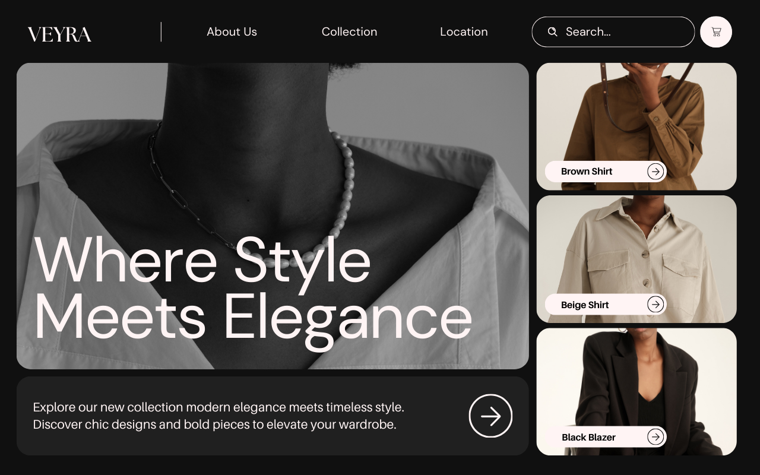

## **5. Technical Requirements**

* Platform: WordPress + WooCommerce or Shopify.
* Languages: HTML5, CSS3, JavaScript.
* Hosting: SSL-enabled, scalable server.
* Security: Regular backups, firewall, malware protection.
* Payment: PayFast, PayPal, Stripe integration.

## **6. Timeline & Milestones**

|  |  |
| --- | --- |
| **Phase** | **Duration** |
| Planning & Research | 1 week |
| Design Mockups | 1 week |
| Development | 2 weeks |
| Testing & Review | 1 week |
| Launch | 1 day |

## **7. Budget**

|  |  |
| --- | --- |
| **Item** | **Cost (ZAR)** |
| Website Design | 4,500 |
| Development & E-commerce | 9,000 |
| Hosting & Domain (1 year) | 1,500 |
| Maintenance (monthly) | 500 |

**Total:** ZAR 15,000

## **8. References**

* Canva, 2025. *Black and White Minimalist Rounded Desktop Prototype.* [Online] Available at: <https://www.canva.com/design/DAGwIfn1DQ8/bTuahq9ge84G5Z3703GXQg/view?mode=prototype>. Accessed [13 August 2025].
* McHoes, A.M. & Flynn, I.M., 2018. *Understanding Operating Systems*, 8th ed. Boston: Cengage Learning.
* Shopify, 2025. *Shopify Help Center*. [Online] Available at: <https://help.shopify.com/>. Accessed [12 August 2025].
* W3C, 2025. *Web Content Accessibility Guidelines (WCAG)*. [Online] Available at: <https://www.w3.org/WAI/>. Accessed [13 August 2025].